Day 57: Implementation of 512:1 MUX Using 4:1 MUX

Introduction: A 512:1 Multiplexer selects one input from 512 data inputs using 9 select lines. It can be implemented using multiple 4:1 multiplexers.

Design
- Inputs: 512 data inputs (I[511:0])
- Select lines: 9 (S[8:0])
- Output: 1 bit (Y)
- Basic component: 4:1 MUX

Working Principle:The 512:1 MUX is constructed using 4:1 multiplexers arranged in multiple stages.
- Stage 1: 128 MUXes
- Stage 2: 32 MUXes
- Stage 3: 8 MUXes
- Stage 4: 2 MUXes
- Stage 5: 1 MUX
A total of 171 4:1 multiplexers are required. The select lines control which input reaches the final output.
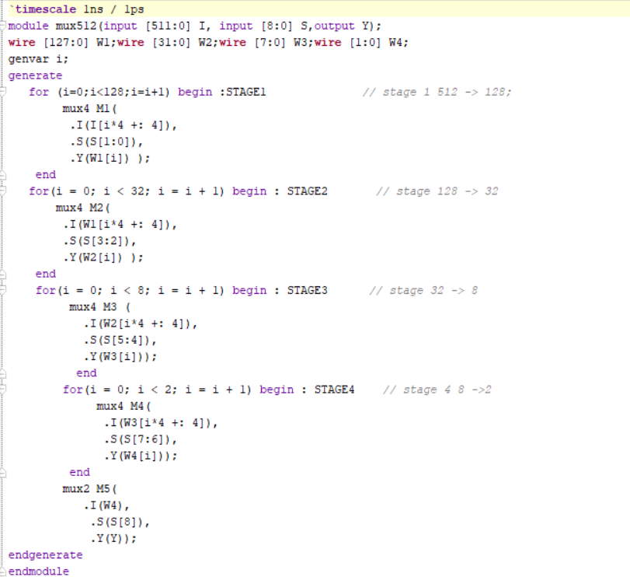

Testbench:The testbench applies different input patterns and select-line combinations to verify the output of the 512:1 MUX.

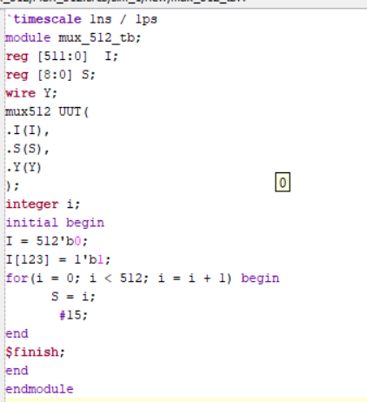

Waveform: The simulation waveform verifies the output for different select-line combinations. The output Y follows the input selected by S[8:0].

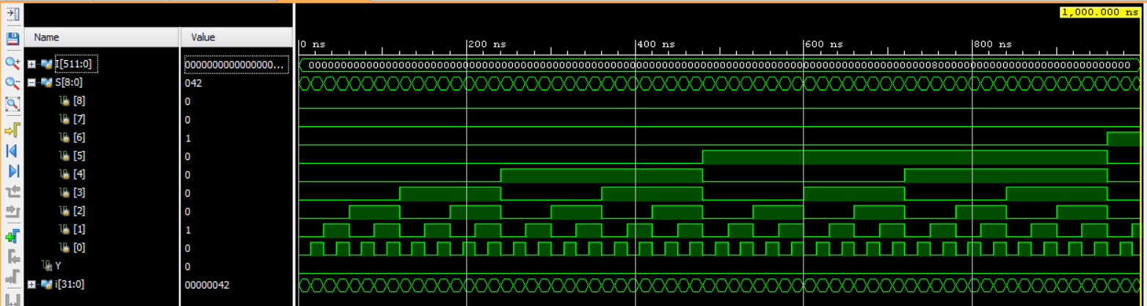

Schematic: The RTL schematic shows the hierarchical implementation of the 512:1 MUX using multiple 4:1 multiplexers connected in stages.

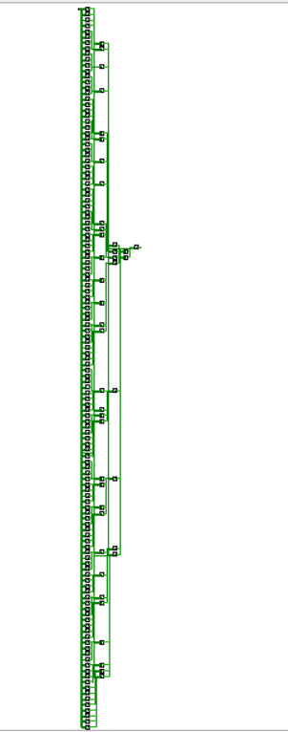

Observation
The 512:1 MUX selects one of 512 input signals using 9 select lines. The design demonstrates how higher-order multiplexers can be constructed using lower-order multiplexers.

#PHANEENDRA.SINGUSAU

